That Game

Design Document

General overview

**Game genre - 3D platformer with the elements of puzzle, stealth and action**

**Visual style**

3D assets style - Low-poly minimalism

Visual setting – our world – TV show with decorations and backstage

Color palette is mostly bright

Props look artificial, but characters feel like alive

References:

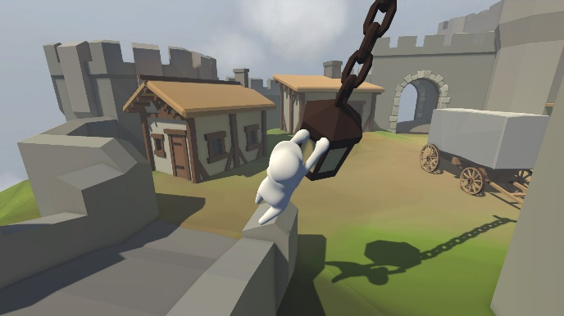 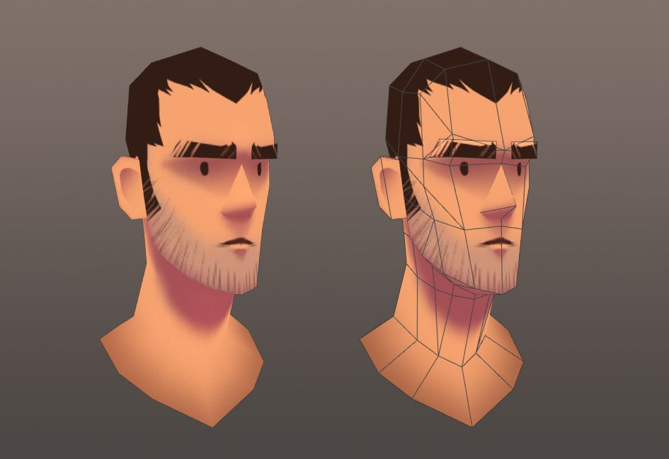

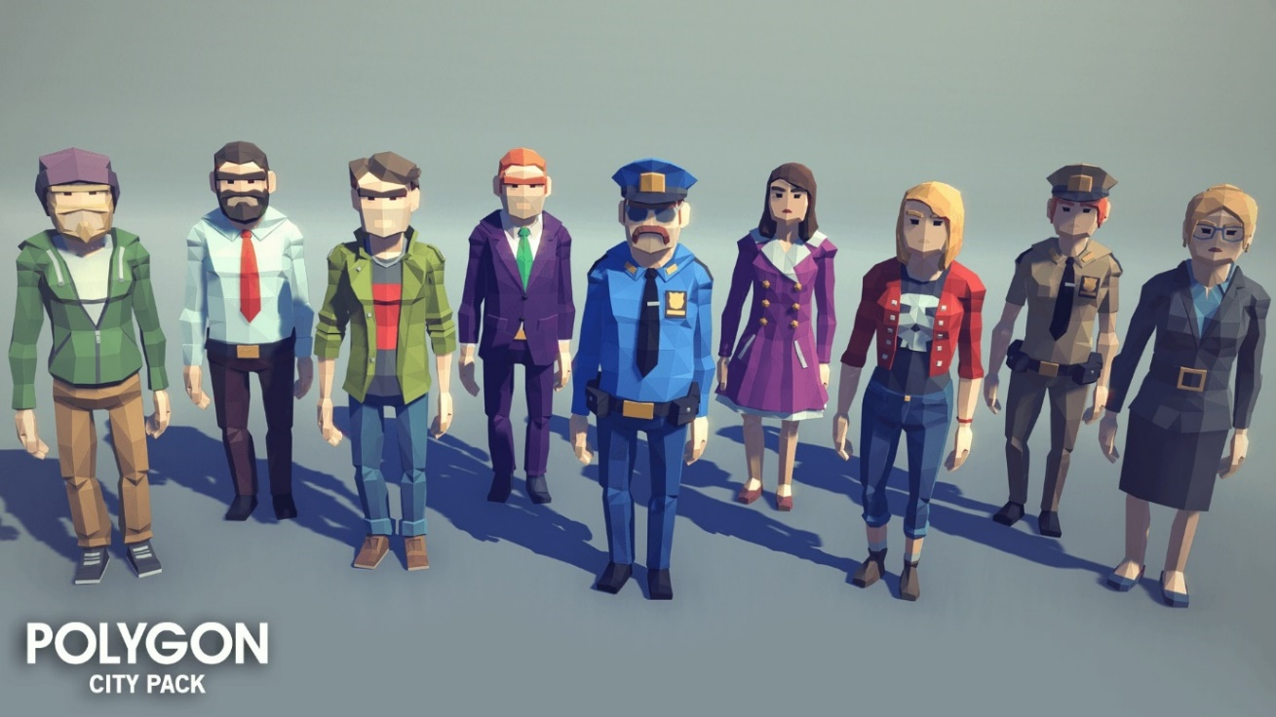

**Player control**

Character is human

Camera (mouse look) – 3rd person view (independent of character’s rotation)

WASD – walk / control mid-air

Space – jump

E – interact

LMB – Grab

Additional:

Space (mid-air) – climb / wall jump

LMB (mid-air near rope) – rope riding

**Core gameplay**

During the game player has to overcome obstacles, avoid getting close to the enemies, set traps and solve simple puzzles

Win conditions

Keep at least 1 HP

Set all the traps on the levels with traps, solve the puzzle on the levels with puzzle or both  
Reach the door (it gets unlocked after all the traps are set or/and puzzle is solved)

Make it before the timer expires on the levels with timer

Lose conditions

Lose all HP (by getting catched by enemies or stepping on a trap)

Miss the timer on the levels with the timer

**Gameplay progress**

Through the levels obstacles, enemies and puzzles become harder to overcome and solve

Gameplay systems and mechanics

**Systems**

*Walk* – just an average person walk

*Jump* – should feel realistic, but still comfortable for platformer

*Mouse look* – 3rd person camera that can fly around character without affecting his rotation

**Mechanics**

*Grab* – small objects can be grabbed and replaced to the floor or another object

*Floor button* – step or put a small object on the button to activate it. If all the buttons on the level are activated and rest win conditions completed, it will open the door leading to the next level

*Interaction* – on each level there’re preset locations with interactable props (traps, hiding spots)

*Ragdoll* – can be activated when player stepped on a trap

*Hiding spots* – some bushes / trash containers, where Boris jumps to evade or stay safe from enemies (hat is exposed – joke on the stealth games genre). They are highlighted with the outline while chase

*“Coins”* – any collectibles that are NOT necessary for level completion. Player gets better score and hears applause after collecting “coins”

*Traps* – being triggered by the player or the enemies, traps can “catch” them  
All the traps kind of change geometry of the level. It makes player think carefully before setting traps. If player gets catched by a trap, it can be set once again on the same spot.

*Extra abilities* – sometimes to collect “coins”, player has to perform “tricks” using *extra abilities*. They are also useful to overcome some obstacles and solve the puzzle or escape from the enemies.

Traps types – their effect:

Small glass balls – restrict movement for a while (character becomes ragdoll)

Launch pad – sends you in air (ragdoll), attracting enemies from nearby

Banana peel – slide forward anim restricting control, then fall as a ragdoll

Lifebouy – it falls down on the body around belt, restricts jump height and grabbing for a while, activates walk animation without arms moves

Pie in the face – a pie is launched in character’s face, making it fall as ragdoll, restricts view with pie pieces (on the screen) and move speed for a while

Extra abilities:

*Wall jump*– appropriate edge or object on the wall allowing player to bounce from it; to perform player has to collide the object and press jump button

*Climbing* – something like railing over the ledge allows player to climb on the height

*Rope riding* – something like rope allows player to overcome the distance

Obstacles types – their role in level geometry:

Small (<1m) – jump over / grab and use as support

Pit – jump over

Medium (~1.5m) – put small next to and jump over / climb / wall jump

Big (>2m) – go around / make a tower of small objects to jump on / small object + wall jump/climb

Wall – level boundaries

AI:

Enemies have two states: patrolling and chasing

You can escape from enemies hiding in hiding spots

You can lead enemies to the traps to win a few seconds

**Parameters**

Walk speed should feel like average person walking - 250 cm/s

Jump - quick push, quick fall, <1sec mid-air, ~1m height - 550 cm/s

Gravity should accompany the jump – 1.5

Level design

1. Basic movement training (backstage)
   1. Straight field
   2. Small objects to jump over
   3. Trap small glass balls to set
   4. Trap small glass balls to get catched

Storyline

**Lore**

Main character is a show man named Boris. He was famous for toilet humor on local TV. And now he works as an actor in TV series for kids. His role is the bad guy setting traps and making acts of sabotage to the good guys. His stage name is Mr. Bad. He’s not really enjoying the job, but his sense of humor makes him a star of this show. Boris is respected by the director and colleagues, so the atmosphere of communication is in his hands. Most parts of scenario become more powerful with his improvisations. Although their sponsor is always angry because of the bills issued by Boris. People are afraid of losing their job, so they make a tiny pressure on Boris in small talks. It’s becoming harder to generate jokes, because everything looks cheap and similar. Boris is tired of an unpromising career. He’s going to risk it and make the show great.

**Scenario**

The first mention of each new mechanics is highlighted in Red

Act 1

Backstage – “I can’t stay still”

Boris is preparing to show, warming up and testing the new small glass balls trap. He didn’t tell anyone about it for people to be naturally surprised seeing it on the stage. After setting a trap he gets trapped by another small glass balls trap that he forgot about. Getting rid of it, he comes to the stage entry. He comes in, applause.

Villain hideout – “Today they love me. But tomorrow…”

Boris is alone on the scene. His goal is to get outside and collect “coins” (optional). There’re multiple boxes and the locked door leading outside. To open it Boris has to push the floor button*.*

Act 2

Outside – “It’s show time”

Boris comes out of a portable toilet in a park, following with the laughter of the audience. He goes towards a fence and sees a sign “beware of people”. First enemy is staying still, so Boris can easily stay unnoticed. Just in case there are some hiding spots. He sets the first small glass balls trap and takes the height to spectate. His trap worked out. Boris laughs. Everything becomes silent. Trapped actor doesn’t know how to react. “Cut!”

Park – “No more tricks, Boris!”

“Action!”. Boris doesn’t look upset or nervous. His plan is only beginning. Now there’s a lot more “coins” to collect, so Boris has to do his usual job without any tricks.

Act 3

Maze – “I’m the Mr. Bad”

Boris prefers to get out of the maze faster, so this level has a timer. After setting some traps Boris takes the height to spectate. He laughs again.

Playground – “I’m not that old”

People seem to get used to small glass balls traps. It’s not harmful, so show goes on. Anyway, the next scene is not about jokes. People can fall down and break the limbs. There Boris decides to show his movement abilities: rope riding, wall jump and climbing. Next few levels will reveal Boris’s abilities and explain how to use them for solving puzzles.

Act 4

Space ships launch station – “Euphoria”

Decorations are amazing. Boris was told not to break something expensive. But he’s not afraid of risking. He sees an opportunity to test a new trap – launch pad. Moving around with some extra abilities, Boris collects some coins placed in the difficult spots. And after setting a trap and solving a puzzle, he takes the height to spectate. It looks surprising, but very funny. Boris laughs. Audience is happy. Team feels tense.

Kid’s dream (Alice in the wonderland for the reference) – “So far so good”

Everything looks like the reality ends here. Even though Boris has a plan, this place looks too pure to set any traps. He decides to perform more tricks. So there’s a lot of “coins”, the goal is to solve the puzzle and open the door.

Act 5

Moon – “My knees don’t hurt”

Everything looks like decoration, but somewhy there’s Moon like gravity. Boris feels brave enough to test his new traps: banana peel and lifebuoy. It doesn’t feel like it’s bothering people. He sets a lot of traps on the next few levels. He only hears applause. In his head it’s the success.

Mountains – “It’s getting cold”

Actors are freezing, so there’s a timer for those levels. Next few levels will contain most amount of enemies, but allow to use all the extra abilities while collecting “coins” and setting traps. Boris feels like it’s the best chance to make the show great. So he tries his best.

Act 6 (last)

Chocolate factory – “Boris’s legacy”

Boris tries new trap – pie in the face. Audience reaction makes Boris think he’s doing great. There’s not a lot of enemies nearby. No more puzzles. He just sets all the traps without a big risk. He doesn’t perform a lot of tricks. It becomes empty and more silent.

Last level – “What have you done?”

Boris sets a banana peal trap near “chocolate mixer”. Actor falls down. Decorations smoothly disappear. Boris finds himself in a real factory. He smiles insanely and whispers: “Cut…”

Appearance

**Animations**

1. Player
   1. Idle
   2. Walk (forward)
   3. Jump (pushing from ground, flying phase, landing)
   4. Grab (different variation for each grabbable object)
   5. Set the trap
   6. Hide and go out
   7. Sliding on banana peel
   8. Walk with tied hands by the lifebouy
   9. Climbing
   10. Rope riding
   11. Stand up from ragdoll
2. Enemy
   1. Idle
   2. Patroling (walking)
   3. Chasing
   4. Stand up from ragdoll
   5. Sliding on banana peel
   6. Catch player
   7. Jump
   8. Walk with tied hands by the lifebuoy
   9. Attack player

**Sound design**

Music should feel like heart beat, getting faster while chase, getting slower while hiding or sneaking

Body moves and interactions with environment are accompanied with cartoon-lke sounds, applause and laughter of “audience”

**VFX**

Minimalistic small particles

**User interface**

Only nescesarry things (e.g. timer, coins counter appearing for a few sec)

Minimalistic menu

Additional information about workflow

**Timeline**

No deadlines, just learn and produce